**Pre-requisites:**  
Make sure you open port 8081 in AWS security group  
  
**Installation Steps:**

sudo yum install wget -y

[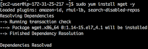](https://4.bp.blogspot.com/-c8dDDRrUuPs/W6U5K5zgAfI/AAAAAAAAAek/pxqUNpn_l68jecwazohXXgOIJ_7K5ePtACLcBGAs/s1600/Screen%2BShot%2B2018-09-21%2Bat%2B1.31.14%2BPM.png)

**Download Java 8**

sudo yum install java-1.8.0-openjdk.x86_64 -y

you can confirm java is installed by typing the below command:  
java -version  
  
Execute the below command to navigate to /opt directory by changing directory:  
  
cd /opt  
  
**Download Nexus**  
sudo wget http://download.sonatype.com/nexus/3/nexus-3.26.1-02-unix.tar.gz

**Extract Nexus**  
sudo tar -xvf nexus-3.26.1-02-unix.tar.gz  
sudo mv nexus-3.26.1-02 nexus  
  
**Create a user called Nexus**  
sudo adduser nexus  
  
**Change the ownership of nexus files and nexus data directory to nexus user.**  
sudo chown -R nexus:nexus /opt/nexus  
sudo chown -R nexus:nexus /opt/sonatype-work

**Add Nexus as a user**

sudo vi /opt/nexus/bin/nexus.rc

change as per above screenshot by removing # and adding nexus

[](https://4.bp.blogspot.com/-khBXYQvFgg8/XOAzq1unQcI/AAAAAAAABCg/yjPDfs8jR0ohDcspAt4T9gcREG6mfjA3ACLcBGAs/s1600/Screen%2BShot%2B2019-05-18%2Bat%2B11.32.05%2BAM.png)

**Modify memory settings in Nexus configuration file**  
  
sudo vi /opt/nexus/bin/nexus.vmoptions

Modify the above file as shown in below:

[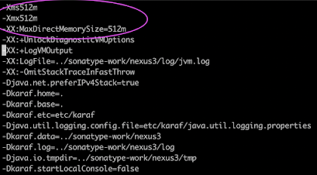](https://1.bp.blogspot.com/-i-J2iwm8-Bw/X0gn1WGyIDI/AAAAAAAAC8w/FjKRdIuTlD4RzGueeeSMtX8uRmzQaSDIgCLcBGAsYHQ/s1004/512%2Bkey.png)

-Xms512m  
-Xmx512m  
-XX:MaxDirectMemorySize=512m

after making changes, press wq! to come out of the file.  
  
**Configure Nexus to run as a service**  
  
sudo vi /etc/systemd/system/nexus.service  
Copy the below content highlighted in green color.

[Unit]

Description=nexus service

After=network.target

[Service]

Type=forking

LimitNOFILE=65536

User=nexus

Group=nexus

ExecStart=/opt/nexus/bin/nexus start

ExecStop=/opt/nexus/bin/nexus stop

User=nexus

Restart=on-abort  
[Install]

WantedBy=multi-user.target

**Create a link to Nexus**  
sudo ln -s /opt/nexus/bin/nexus /etc/init.d/nexus  
  
**Execute the following command to add nexus service to boot.**  
  
sudo chkconfig --add nexus  
sudo chkconfig --levels 345 nexus on  
  
**Start Nexus**  
sudo service nexus start

[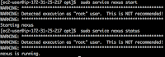](https://2.bp.blogspot.com/-wM6hGxr6WV0/W6U65zJ2OHI/AAAAAAAAAfQ/Ps0aml3MYHo49mOZBRXgLXCZCosVfAE6wCLcBGAs/s1600/Screen%2BShot%2B2018-09-21%2Bat%2B1.39.08%2BPM.png)

**Check whether Nexus service is running**  
sudo service nexus status

[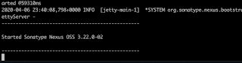](https://1.bp.blogspot.com/-86p0YO_4ibU/XovO2MM4A8I/AAAAAAAABtI/rt9udsz6Sc4TSAipr5mSt3L5fbHetP9TgCLcBGAsYHQ/s1600/nexus-3-22.png)

**Check the logs to see if Nexus is running**  
tail -f /opt/sonatype-work/nexus3/log/nexus.log

You will see Nexus started..If you Nexus stopped, review the steps above.

Now press Ctrl C to come out of this windows.

Once Nexus is successfully installed, you can access it in the browser by URL - [http://public_dns_name:8081](http://public_dns_name:8081/)

Click on Sign in link

user name is admin and password can be found by executing below command:  
  
sudo cat /opt/sonatype-work/nexus3/admin.password

[](https://1.bp.blogspot.com/-6MgdjjugZV0/XZQCmCQsIjI/AAAAAAAABQw/NWUQAEgcAkM7T_fcC2tlasiQauuShLiwgCLcBGAsYHQ/s1600/Screen%2BShot%2B2019-10-01%2Bat%2B8.50.21%2BPM.png)

Copy the password and click sign in.  
Now setup admin password as admin123

[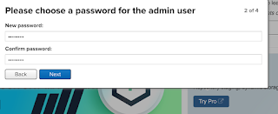](https://1.bp.blogspot.com/-VJfk7DDW5bo/XZQC86R1uHI/AAAAAAAABQ4/C1l4lLxWeG0QAKu0uKST4UJmnFm6Y1ZpgCLcBGAsYHQ/s1600/Screen%2BShot%2B2019-10-01%2Bat%2B8.52.09%2BPM.png)

You should see the home page of Nexus:

[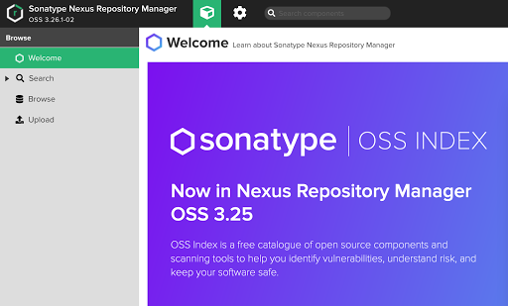](https://1.bp.blogspot.com/-sUE_mQ_j1TQ/X0goUA5IsCI/AAAAAAAAC84/fgy5CSswI0A8MDeVpaqmIoiKJvI-kIAbwCLcBGAsYHQ/s1768/nexus%2Bhome.png)